**Task Management System for Small Business Owners in Anislag**

_____________

A Project Presented to the faculty of the

College of Computing and

Information Sciences

BISU Balilihan Campus

In Partial Fulfillment for the

Requirements of the Subjects

System Analysis and Design

Hayian Hrienz M. Requina

**Chapter 1**

**THE PROBLEM AND IT’S SCOPE**

# Rationale

In today’s modern era, technology automation plays a crucial role in improving how people work and manage operations. The internet allows small business owners to take better control over their activities by making communication, task handling, and business processes more efficient. With proper automation, businesses can avoid delays, improve task monitoring, and boost overall productivity. Without automation, many businesses struggle with disorganized tasks and missed opportunities due to manual processes.

The Task Management System for Small Business Owners in Anislag uses modern technologies to improve daily operations. It is designed as a centralized, digital platform that helps business owners create, assign, and track tasks in real time. Key features include task prioritization, automatic reminders, and progress tracking. These tools help users stay organized and reduce the risk of forgetting important tasks. The system also has a user-friendly interface to make sure it’s easy to use even for those with little technical experience.

Despite their hard work, many small business owners face daily challenges in managing tasks efficiently. Most still rely on notebooks, verbal instructions, or spreadsheets, which can be disorganized and hard to track. As business activities grow, manual methods become harder to manage, leading to confusion, missed deadlines, and lowered productivity. These challenges affect overall performance and the ability to scale their businesses smoothly.

To solve these problems, the proposed system provides a structured and automated solution. It replaces inefficient manual methods with a well-organized platform for managing tasks. With real-time task tracking, automatic notifications, and easy navigation, the system helps business owners stay on top of their work. This allows them to focus more on growing their businesses instead of dealing with task-related issues. The researcher aims to support Anislag’s small businesses by offering a solution that improves their operations now and helps them expand in the future.

# Literature Background

A study on Time Tracking Software for Small Business Owners highlights the importance of automated tools in improving productivity and workflow management. According to Peter Michael McNamara (2016), user-friendly time tracking applications significantly encourage adoption among small business owners, especially when integrated with task management systems.

Additionally, Peter Michael McNamara (2016), found that businesses implementing time tracking systems experienced increased efficiency by effectively monitoring work hours, managing deadlines, and optimizing resource allocation. This aligns with the objective of this study, which aims to develop a Task Management System that incorporates time tracking features to help entrepreneurs manage their daily operations more effectively.

Furthermore, research by Smith and Johnson (2018) emphasizes that digital task management solutions reduce human error and enhance accountability within businesses. The integration of time tracking with task management not only improves workflow organization but also provides valuable insights into employee productivity patterns. With real-time tracking and automated reporting, small business owners can make data-driven decisions to streamline operations, allocate resources efficiently, and improve overall business performance.

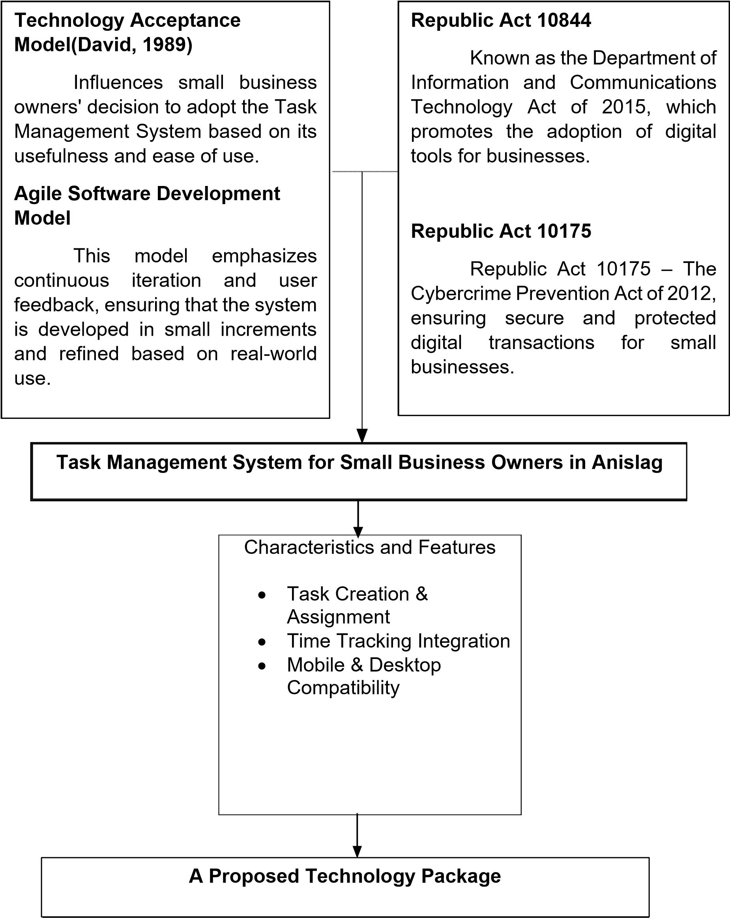

**Figure 1.0 Theories and Conceptual Framework**

This study is based on the Technology Acceptance Model (TAM) by Davis (1989) and the Agile Software Development Model. The Technology Acceptance Model (TAM) suggests that a system's adoption is influenced by two main factors: perceived usefulness (PU) and perceived ease of use (EOU). Small business owners are more likely to use the Task Management System if they find it helpful in managing tasks and easy to navigate.

Meanwhile, the Agile Software Development Model emphasizes continuous iteration and user feedback, ensuring that the system is developed in small increments and refined based on real-world use. This iterative approach allows for flexibility in system enhancements, making it adaptable to the evolving needs of small business owners.

This study is supported by Republic Act 10844, also known as the Department of Information and Communications Technology (DICT) Act of 2015. This law promotes the adoption of digital tools and infrastructure to improve efficiency, particularly in small businesses. By encouraging digital transformation, it aligns with the study’s objective of developing a technology-based Task Management System.

Another relevant legal basis is Republic Act 10175, the Cybercrime Prevention Act of 2012. This law ensures the security and protection of digital transactions, safeguarding businesses from cyber threats. As the proposed system involves digital time tracking and data management, this act serves as a foundation for implementing secure and reliable digital solutions.

**The Problem**

# Statement of the Problem

This study aims to develop a Task Management System to help small business owners in Anislag organize, track, and assign tasks more easily.

Specifically, it seeks to answer the following questions:

1. What current problems do small business owners in Anislag face when managing their tasks?
2. How do small business owners currently track and organize their tasks?
3. What challenges do small business owners encounter in delegating and monitoring tasks?
4. What is the profile of the Task Management System in terms of:

a. System Rules

b. Context Diagram

c. Program Hierarchy

d. Task Tracking and Assignment Process

e. Process Specification

f. Database Design

g. Functional Requirements

h. Technical Requirements

i. Cost-Benefit Analysis

j. User Interface (UI)

1. What action plan has to be designed and implemented to ensure the system effectively improves task management and productivity?

**Scope and Limitations**

This study focuses on developing a Task Management System for small business owners in Anislag to help them organize, track, and manage tasks efficiently. The system includes features like task creation, editing, deletion, assignment, and tracking, along with notifications for deadlines. It will have a user-friendly interface for easy navigation and may be developed as a standalone or web-based platform. The goal is to improve productivity and workflow for small businesses.

The system is designed only for small business owners in Anislag, making it unsuitable for larger businesses. It focuses only on task management and does not include payroll, inventory, or financial tracking. If web-based, an internet connection will be required, which could be a challenge in some areas. The system will be optimized for desktop and mobile, but real-time syncing across multiple devices may be limited. Advanced reporting features are also not included in this version. Despite these limitations, the system aims to provide a simple and effective solution for managing tasks.

**Significance of the Study**

The researcher believes that the analysis of this study will be useful for the following stakeholders.

**Small Business Owners.** The system aims to simplify task organization, ensuring better productivity and time management. It helps entrepreneurs stay on top of their tasks, reducing manual workload and improving business operations.

**Local Economy.** By improving the efficiency of small businesses in Anislag, the system contributes to the overall growth and sustainability of the local economy, fostering entrepreneurship and business development.

**Future Researchers.** This study serves as a reference for future researchers interested in task management solutions, small business efficiency, and system development, providing insights into digital transformation in smallscale enterprises.

**Research Methodology**

# Research Design

This study employs a descriptive research design to explore how small business owners in Anislag manage their daily tasks and to determine how a task management system can enhance their workflow. A quantitative approach is used to collect data on existing task management challenges, measure their impact on business operations, and evaluate the potential effectiveness of the proposed system. By analyzing survey responses, the study aims to provide a data-driven understanding of the needs of small business owners and how digital task management solutions can improve efficiency, organization, and productivity.

# Researcher Environment and Participants

This study takes place in Anislag, a growing community where small businesses play a vital role in the local economy. Many business owners in the area juggle multiple responsibilities, often relying on traditional methods such as handwritten notes, verbal reminders, or simple mobile applications to keep track of tasks. However, these manual approaches can lead to disorganization, missed deadlines, and inefficient workflow management, making it difficult for entrepreneurs to optimize their business operations.

Recognizing these challenges, this study aims to introduce a Task Management System specifically designed for small business owners in Anislag.

The system seeks to provide a structured and efficient way to organize daily tasks, set priorities, and track progress all while being user-friendly and accessible to non-technical users.

To ensure the study gathers relevant insights, three (3) small business owners from Anislag were selected as respondents using a purposive sampling method. These individuals were chosen based on their active involvement in managing their businesses and their experience with task management challenges. Their feedback will be crucial in assessing the practicality and usability of the proposed system, ensuring that it effectively meets the needs of local entrepreneurs.

# Data Gathering Instrument

Guide questionnaires and observations were used in this study to gather quantitative data about how small business owners in Anislag manage their daily tasks. These instruments were chosen to identify common task-related problems and evaluate how a digital task management system could help solve them. Guide questionnaires allowed the researcher to collect consistent and measurable responses, while observations provided context to the answers by showing how tasks were handled in actual business settings.

The researcher asked permission from small business owners in Anislag to conduct the survey and observe their usual workflow. The questionnaire focused on how they organize, track, and complete tasks, what difficulties they encounter, and their willingness to use a task management system.

Although the study focused on quantitative data, observations were used to better understand how these task-related issues appear in real-life situations. This helped the researcher interpret the questionnaire results more effectively and identify the features that would be most useful in the system.

# Research Procedure

The Agile Model is used in this study to create the Task Management System for Anislag's small business owners. By emphasizing adaptability, ongoing cooperation, and iterative development, the agile methodology makes sure that the system satisfies the unique requirements of its users. The following stages make up the research process:

# Phase Ⅰ: Concept & Requirement Gathering

The researcher identified the common challenges small business owners in Anislag face in task management. Surveys and observations were conducted to gather insights into current practices, pain points, and system requirements.

# Phase Ⅱ: Design & Prototyping

A simple version of the system was created with an easy-to-use design for small business owners. Business owners tested the design and shared their thoughts on how it worked. Changes were made based on their feedback before moving forward.

# Phase Ⅲ: Step-by-Step Development & Feedback

The system was built in small steps, testing each part along the way. Important features like adding tasks, tracking progress, and editing tasks were added one by one. Business owners tried out each version and gave suggestions to improve it.

# Phase Ⅳ: Continuous Testing & Refinement

The system was tested regularly to find and fix issues early. Small business owners used it and shared their experiences to make sure it worked well for them. Quick changes were made based on their feedback to keep improving the system. Phase Ⅴ: **Deployment & Continuous Evaluation**

The final version of the system was introduced for real use. Small business owners started using it daily and gave feedback on how helpful it was. Their suggestions helped make the system even better over time.

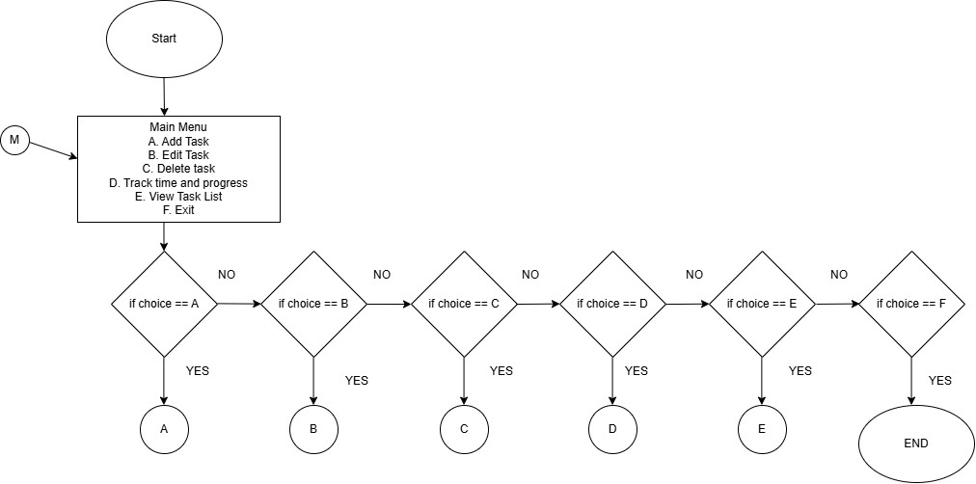

**F**

**igure 2.0 Flowchart**

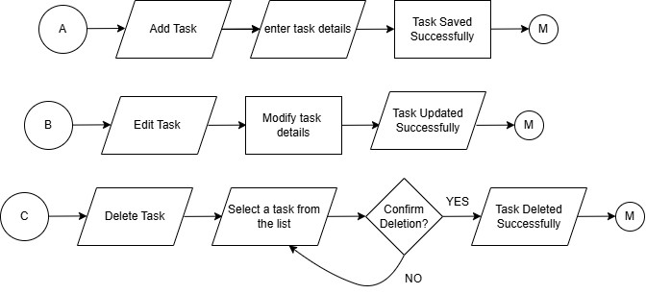

**Figure 2.**

**1**

**Flowchart**

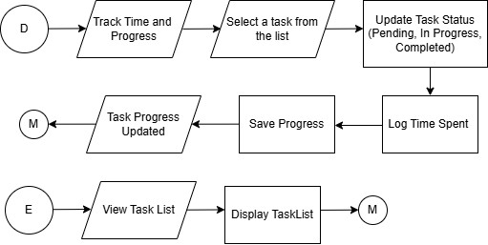

**Figure 2.**

**2**

**Flowchart**

**Figure 3.0 Gantt Chart**

# Definition of Terms

The following terms are operationally defined in order to have a clearer understanding of the matters involved in this study.

**Task Management System** – A software application designed to help small business owners organize, monitor, and manage their daily tasks more efficiently.

**Small Business Owners** – Entrepreneurs in Anislag who manage and operate their own businesses, handling multiple responsibilities and tasks.

**Task Creation** – The process of adding new tasks to the system, including setting descriptions, deadlines, and priorities.

**Task Editing** – Modifying details of existing tasks such as deadlines, descriptions, or priority levels.

**Task Deletion** – Permanently removing a task from the system when it is no longer needed.

**Task Tracking** – Monitoring the status and progress of tasks to ensure timely completion.

**Notifications** – Automatic alerts or reminders generated by the system to inform users about due or overdue tasks.

**User Interface (UI)** – The visual design of the system that allows users to interact with and navigate the features easily.

**System Testing** – The process of checking the system for errors and ensuring all functions work properly before full use.

**Deployment** – Launching the system for actual use by small business owners after development and testing.